# **Bluetooth Network Encapsulation Protocol (BNEP)**

* Used to transport common networking protocols over the Bluetooth media such as IPv4 and IPv6.
* Packet format based on Ethernet II/ DIX Framing as defined by IEEE 802.3 thus it’s similar to Ethernet.
* Used by the PAN profile.

**Networking Details**

* This protocol is implemented using connection oriented L2CAP channels.
* Bluetooth is considered to be a transmission media in the same OSI layer as Ethernet, Token Ring, ATM, etc.
* L2CAP is considered to be the Bluetooth Data MAC (Media Access Control) Layer.
* BNEP specifies a minimum L2CAP MTU of 1691 bytes1.
* The accepted rules of network connectivity and topology as defined for IEEE 802.3 (e.g. switching and routing) SHALL be applied to Bluetooth in a manner consistent with IEEE 802.3 media.
* The Bluetooth BD_ADDR address space is administered by the IEEE, and is assigned from the Ethernet address space. This means that it is possible to build a Bluetooth network access point as a bridge between Bluetooth devices and an Ethernet network.

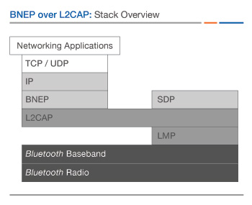

**Packet Details**

* BNEP removes and replaces the Ethernet Header with the BNEP Header.
* Finally, both the BNEP Header and the Ethernet Payload is encapsulated by L2CAP and is sent over the Bluetooth media.

 The maximum payload that BNEP SHALL accept from the higher layer is equal to the negotiated L2CAP MTU (minimum value: 1691), minus 191 bytes (or 187 bytes if an IEEE 802.1Q tag header [9] is present) reserved for BNEP headers. This way it can be assured that enough frame buffer space is reserved to transmit all BNEP. The minimum payload that BNEP SHALL accept from the higher layer is zero; BNEP is not required to pad payloads to the Ethernet minimum size (46 bytes).